Differential gene expression analysis using DE-Seq2 Bioconductor package

- Bellat et al performed a RNA-seq analysis of MDA-MB-468 cells treated with PBS (control), salinomycin, dasatinib, or the drug combination Sal + Das for different time points (BMC Cancer 2020 Jul 16;20:661). The total RNA was extracted, purified and sequenced using Illumina HiSeq 4000 sequencer.

Data processing: The RNA reads were aligned and mapped to the GRCh37 human reference genome by STAR. The transcriptome reconstruction was performed by Cufflinks. The abundance of transcripts was measured with Cufflinks in raw count and Fragments Per Kilobase of exon model per Million mapped reads (FPKM). Gene expression profiles were constructed using the DESeq2 package.

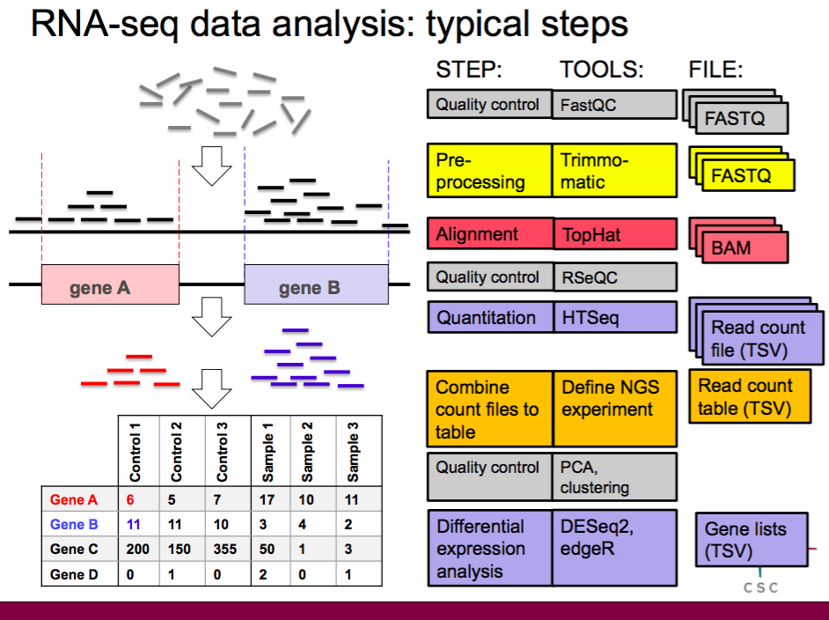

(Image reference: https://chipster.csc.fi/manual/rna-seq-summary.html)

Data given by author: The raw RNA sequencing data (count data) is available in the Gene Expression Omnibus (GEO) database with the accession number GSE135514.

Data for practical:
- The RNA-seq count data for control and salinomycin-treated samples for 24 hr is given (count_data.csv).
- The metadata for this analysis is given (metadata.csv)

- In order to analyse this data, read the files and match columns of the count data and the rows of the metadata. Construct a DESeqDataSet object and perform pre-filtering to remove low count genes. Perform transformation of count data for visualization or clustering. A. Explore count matrix after transformation by doing visualization with Heatmap. B. Comment over similarities and dissimilarities between samples (by performing sample clustering of the transformed data). C. Comment on overall effect of experimental conditions (by visualizing PCA plot of samples).

- Perform differential expression analysis and identify how many genes are significantly (adjusted p-values were less than 0.05) expressed in salinomycin treated samples. Visualize differentially expressed genes using MA plot.
Code:
Install required packages:
BiocManager::install("DESeq2")
BiocManager::install("pheatmap")
BiocManager::install("RColorBrewer")
Check &amp; Set path of working directory:
getwd()
setwd()
Read raw count data and save it in a variable:
count <- as.matrix(read.csv("count_data.csv",sep=",",row.names="gene_id"))
Check the count data and check column names of count data:
head(count)
colnames(count)
Read metadata and save it in a variable:
meta <- read.csv("metadata.csv", row.names=1)
Check the metadata and check row names of metadata:
head(meta)
rownames(meta)
Check whether the order column names of the count data and the row names of the metadata same or not.
all(rownames(meta) == colnames(count))

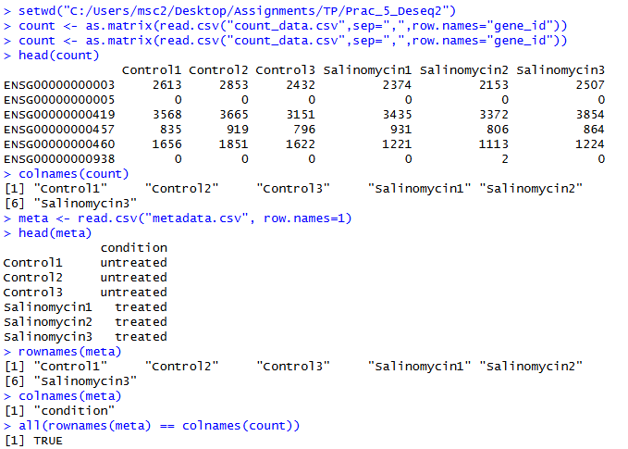
Construct a DESeqDataSet object and check the dimension of data:
library("DESeq2")
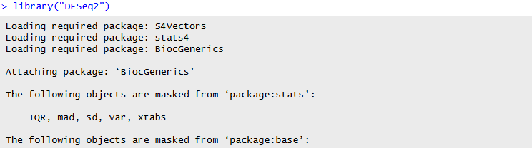
dds <- DESeqDataSetFromMatrix(countData = count, colData =meta, design = ~condition)
dim(dds)
Remove low count genes and then check the dimension of new data:
keep <- rowSums(counts(dds)) >= 10
dds <- dds[keep,]
dim(dds)
dds <- DESeq(dds)
results <- results(dds)
results <- results[order(results$padj),]
head(results)
write.csv(res,"Treated_vs_control_DEG.csv")

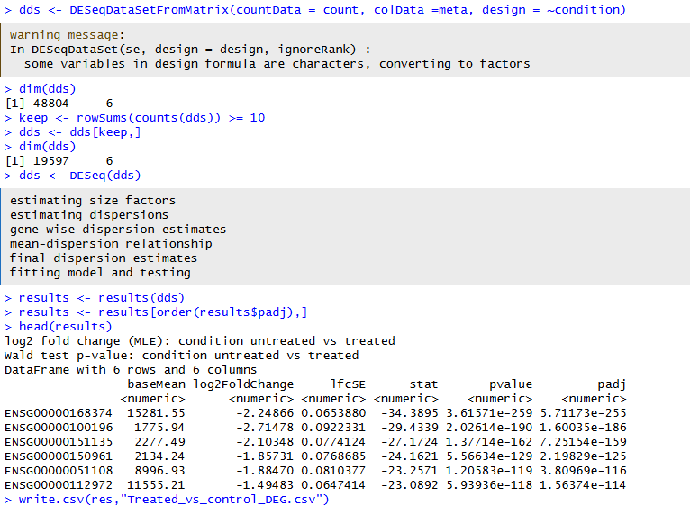

Perform normalization:
vsd <- vst(dds, blind=FALSE)
head(assay(vsd), 3)
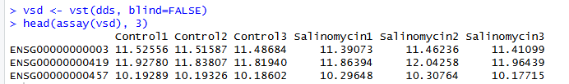
Plot heatmap:
library("pheatmap")
select <- order(rowMeans(counts(dds,normalized=TRUE)),decreasing=TRUE)[1:20]
df <- as.data.frame(colData(dds))
library("RColorBrewer")
sampleDists <- dist(t(assay(vsd)))
sampleDistMatrix <- as.matrix(sampleDists)
rownames(sampleDistMatrix)
colnames(sampleDistMatrix)
colors <- colorRampPalette( rev(brewer.pal(9, "Blues")) )(255)
pheatmap(sampleDistMatrix,
clustering_distance_rows=sampleDists,
clustering_distance_cols=sampleDists,
col=colors)
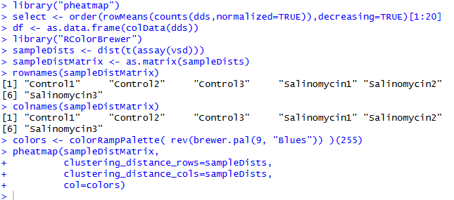
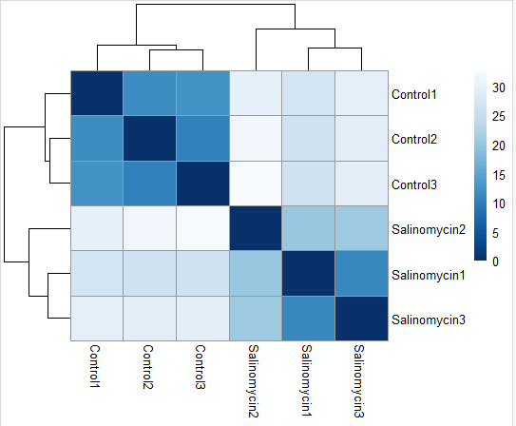
Create PCA plot:
plotPCA(vsd, intgroup="condition")
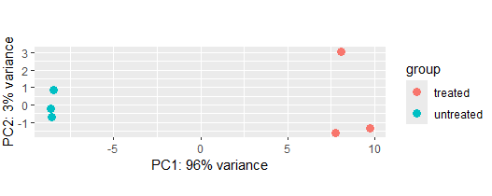
Get list of differentially expressed genes:
res <- results(dds, contrast=c("condition","treated","untreated"), alpha=0.05)
summary(res)
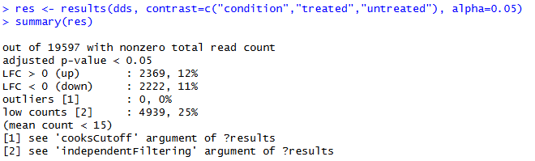
Create MA plot:
pdf("MA_plot.pdf", width=6, height=6)
plotMA(res, ylim=c(-2,2))
dev.off()
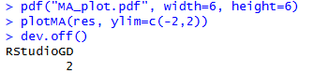
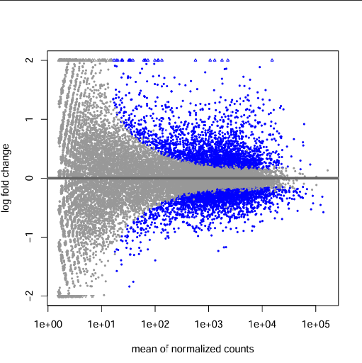
Create volcano plot:
library(EnhancedVolcano)
results <- as.data.frame(res)
results <- na.omit(results)
results$significant <- ifelse(results$padj < 0.05 & abs(results$log2FoldChange) > 1,
"Significant", "Not Significant")

ggplot(results, aes(x = log2FoldChange, y = -log10(padj), color = significant)) +
geom_point(alpha = 0.6) +
geom_vline(xintercept = c(-1, 1), linetype = "dashed") +
geom_hline(yintercept = -log10(0.05), linetype = "dashed") +
theme_minimal()

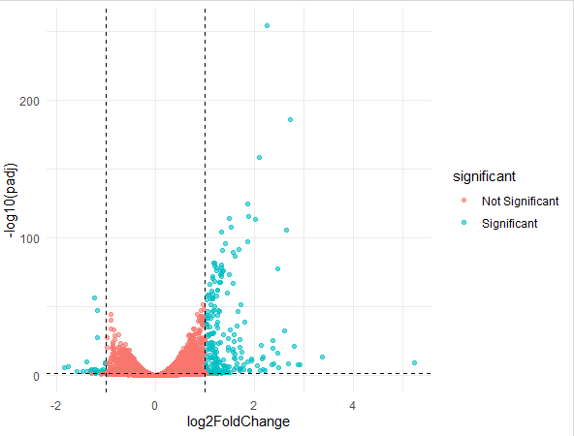

2.A. The heatmap shows six samples: three controls and three salinomycin-treated replicates. Clustering pattern:
- The three control samples cluster tightly together.
- The three salinomycin-treated samples also cluster together, but separately from the controls.
2.B. Similarity: Replicates within the same condition are highly similar, which indicates good experimental reproducibility.
Dissimilarity: There is a clear separation between treated and untreated groups, showing that salinomycin treatment strongly alters gene expression.
This clustering confirms that the treatment effect is biologically meaningful and not random noise.
2.C. Controls cluster on one side and treated samples on the other, it means the treatment condition is the dominant source of variation in the dataset. This supports the conclusion that salinomycin has a global effect on gene expression.
3.a. Out of 19,597 genes with nonzero counts, approximately 4,600 genes were significantly differentially expressed in salinomycin-treated samples compared to controls (adjusted p-value < 0.05).
- Upregulated genes (log2FC > 0): 2,369 (~12%)
- Downregulated genes (log2FC < 0): 2,222 (~11%)
- Low counts filtered: 4,939 (~25%) removed due to low mean expression (<15)
- Outliers: None detected

Salinomycin treatment induces widespread transcriptional changes, with a nearly balanced number of genes being activated and repressed. This bidirectional regulation highlights a strong global impact of the treatment on cellular gene expression programs.

b. An MA plot visualizes differentially expressed genes by plotting the mean expression (average normalized counts) on the x-axis and the log fold change on the y-axis. Each point represents a gene, where most genes cluster around zero (indicating no significant change), while significantly differentially expressed genes appear farther from zero and are highlighted (e.g., in blue). The plot typically shows higher variability at low expression levels and more stable estimates at higher expression levels, helping identify genes that are meaningfully upregulated or downregulated between conditions.

